**Lecture 31 – Population Ecology**

* Population ecology is the study of populations in relation to their environment
  + ( ): a group of individuals of a single species living in the same general area
  + How biotic and abiotic factors influence ( ), ( ),

( ) and ( ) of populations

* Population density is the number of individuals per unit area or volume
  + Typically ( )
  + Population dynamics
    - Addition: birth, immigration (influx)
    - Removal: death, emigration (outflux)
* Population size is affected by birth, rate, immigration and emigration  
  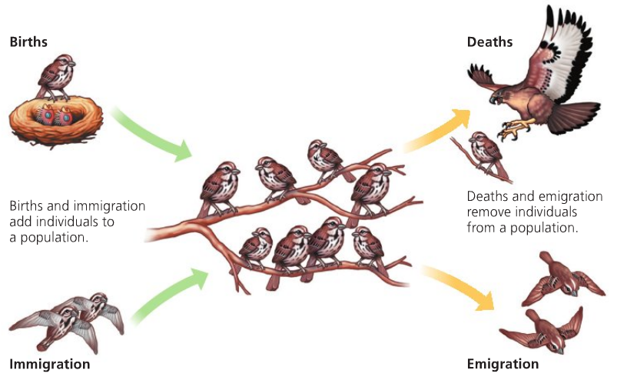
  + Change in population size (*N*) during time interval (*t*) = (**Births** + Immigration) – (**Deaths** + Emigration)
  + Per capita = average # per individual
    - Per capita birth rate: *B = bN*
    - Per capita death rate: *D = mN*
    - Per capita rate of increase: *r = b - m*

*ΔN = B – D = bN – mN = (b – m)N = rN*

*Δt*

* + - Growth at a particular instance in time: *dN = rinstN*

*dt*

* + Example: *b* = 0.05; *N* = 1000. What is the per capita birth rate *B*?
* Different populations exhibit different distribution patterns (Fig. 53.4)
  + ( ): The pattern of spacing among individuals within the boundaries of the population
    - ( ): aggregated in patches; most common pattern
    - ( ): evenly distributed; result of antagonistic social interactions (territoriality); not common
    - ( ): position of individuals independent of others; when abiotic factors are homogeneous; not common
* ( ) (K) is the maximum population size that a particular environment can sustain
  + Shaped by energy, shelter, refuge from predators, nutrient availability, water, suitable nesting sites
* ( ) is the study of vital statistics of populations and how they change over time
  + Data captured through census, mark-and-recapture, sampling
  + ( ): age-specific summaries of survival pattern of a population (Table 53.1, you need to be able to read and understand a life table)
* ( ) shows rate of survivorship for a cohort / population (Fig. 53.6)
  + Type I curve: ( ) death rates during early and middle life, and then   
    ( ) sharply among older-age groups
    - Large mammals, ( )-selected organisms [fill this later]
  + Type III curve: ( ) death rates for the young, then ( ) for those few individuals that survive
    - Organisms that produce very large numbers of offspring, ( )-selected organisms [fill this later]
  + Type II curve: ( ) death rate over the organism’s life span
    - Small mammals, small reptiles, various invertebrates
* Population ( ) affects the future ( ) of the population. (Understand the figure below. You should be able to predict the growth pattern of a country based on the population age structure)

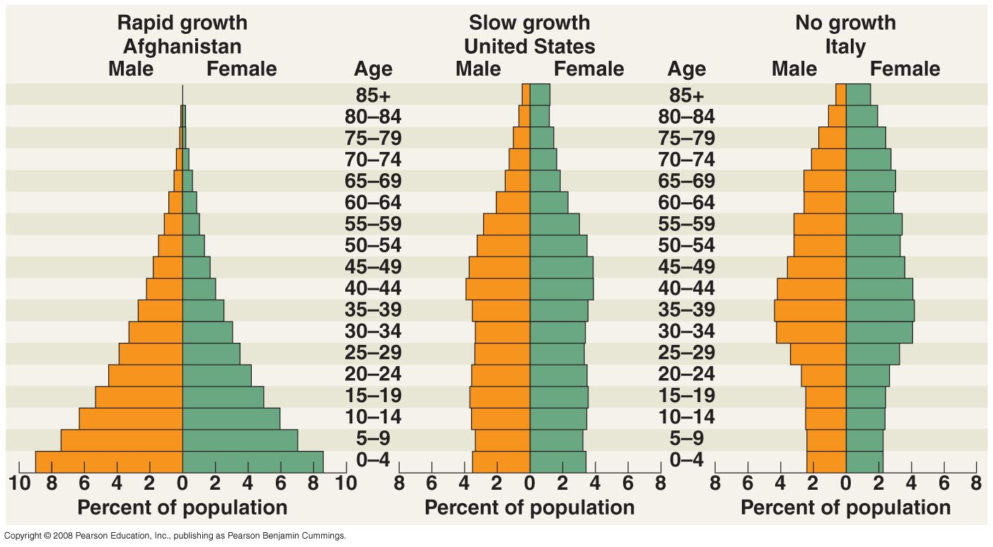

* Populations of all species have the potential to expand when resources are abundant
  + ( ) population growth: population increase under ( ) conditions
  + J-shaped exponential growth curve
  + Characteristic of populations that are introduced to a ( ) environment
  + ( ) on resources, ( ) competition, ( ) predators

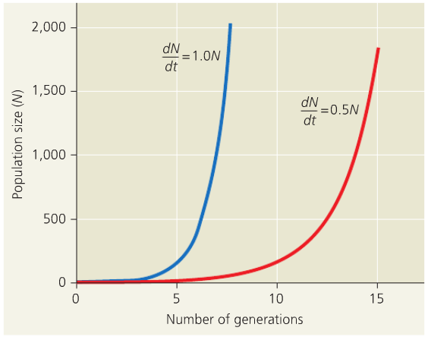

*dN = rmaxN*

*dt*

* Carrying capacity limits population growth
  + ( ) population growth: levels off as population size approaches carrying capacity

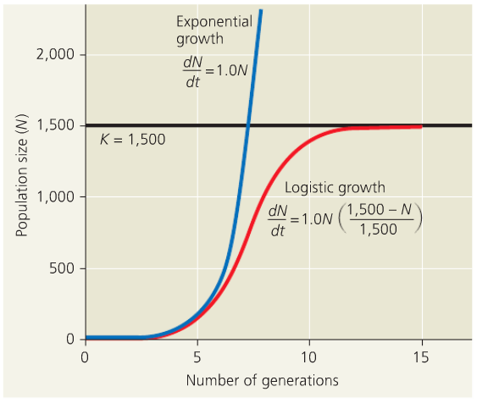

*dN = rmaxN (K – N)*

*dt K*

* Many factors contribute to population dynamics
  + Survival & Reproduction 🡪 ( )
  + ( ): traits that affect an organism’s schedule of reproduction and survival
    - When reproduction begins
    - How often organism reproduces
    - How many offspring are produced
  + There is a ( ) between reproduction and survival
    - Time, energy, nutrients are limiting factors
* Logistic model and life history traits
  + *r*-selection (*r* for growth rate)
    - ( ) environments
    - less-crowded habitats
    - ( ) competition
    - ( ) growth rate
    - produce ( ) offspring
    - ( ) probability of surviving to adulthood
    - favored traits: high fecundity, small body size, early maturity onset, short generation time
    - Examples:
  + *K*-selection (*K* for carrying capacity)
    - ( ) environments
    - living at densities close to K
    - ( ) competition
    - ( ) growth rate
    - produce ( ) offspring
    - ( ) probability of surviving to adulthood
    - favored traits: large body size, long life expectancy
    - Examples:
* Interaction among organisms affects population size fluctuation (Fig. 53.18)